1) Write a program that will take an input from user as number and print all the numbers

from 0 to the given number.

public void numberPrinter()

{

int number;

Console.Write("Please enter a number: ");

number = Convert.ToInt32(Console.ReadLine());

for(int i = 0; i < number+1; i++)

{

Console.WriteLine(i);

}

}

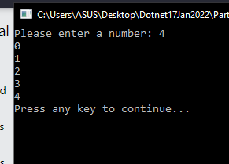

2) Create a program that will find out if the given number is odd or even

public void oddEvenCheckerQ2()

{

int number;

int numLeft;

Console.Write("Please enter a number: ");

number = Convert.ToInt32(Console.ReadLine());

if (number % 2 == 0)

Console.WriteLine(number + " is even number.");

else

Console.WriteLine(number + " is odd number.");

}

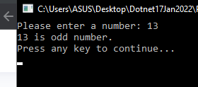

3) Create a program that will take 2 numbers and find out the greatest of the 2

public void greatestFinderQ3()

{

int number1, number2;

Console.Write("Please enter 1st number: ");

number1 = Convert.ToInt32(Console.ReadLine());

Console.Write("Please enter 2nd number: ");

number2 = Convert.ToInt32(Console.ReadLine());

if (number1 > number2)

Console.WriteLine(number1 + " is the greatest");

else if (number1 < number2)

Console.WriteLine(number2 + " is the greatest");

else

Console.WriteLine("Both are the same.");

}

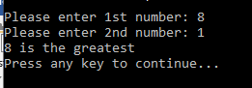

4) Improve the program written in question 3 to find the greatest of 3 numbers

public void greatestFinderQ4()

{

int number1, number2, number3;

Console.Write("Please enter 1st number: ");

number1 = Convert.ToInt32(Console.ReadLine());

Console.Write("Please enter 2nd number: ");

number2 = Convert.ToInt32(Console.ReadLine());

Console.Write("Please enter 3rd number: ");

number3 = Convert.ToInt32(Console.ReadLine());

if (number1 > number2)

{

if (number1 > number3)

Console.WriteLine(number1+" is the greatest");

else

Console.WriteLine(number3+" is the greatest");

}

else if (number2 > number3)

Console.WriteLine(number2+" is the greatest");

else

Console.WriteLine(number3+" is the greatest");

}

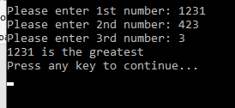

5) Take the minimum and maximum number from user and find all numbers in between

public void numbersBetweenMinMaxQ5()

{

int minNum, maxNum;

Console.Write("Please enter minimum number: ");

minNum = Convert.ToInt32(Console.ReadLine());

Console.Write("Please enter maximum number: ");

maxNum = Convert.ToInt32(Console.ReadLine());

if (minNum > maxNum)

Console.WriteLine("Minimum number is bigger than maximum number.");

else if (minNum < maxNum)

{

for(int i = 1; i < (maxNum - minNum); i++)

{

Console.WriteLine(minNum + i);

}

}

else

Console.WriteLine("Both are the same.");

}

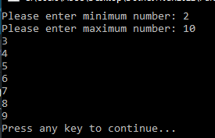

6) Find if a given number is prime

public void primeOrNotQ6()

{

bool prime = false;

int num;

Console.Write("Please enter a number: ");

num = Convert.ToInt32(Console.ReadLine());

prime = primeChecker(num);

if (prime == true)

Console.WriteLine("It is prime number.");

else

Console.WriteLine("It is not prime number.");

}

public bool primeChecker(int num)

{

int i;

for (i = 2; i <= (num - 1); i++)

{

if (num % i == 0)

return false;

}

if (i == num)

{

return true;

}

return false;

}

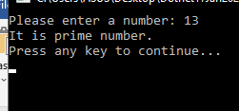 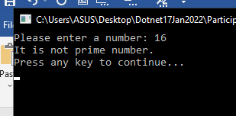

7) Improve the program in 5 to find all the prime numbers between the given numbers

public void primeNumbersFinderQ7()

{

int minNum, maxNum;

bool prime;

Console.Write("Please enter minimum number: ");

minNum = Convert.ToInt32(Console.ReadLine());

Console.Write("Please enter maximum number: ");

maxNum = Convert.ToInt32(Console.ReadLine());

if (minNum > maxNum)

Console.WriteLine("Minimum number is bigger than maximum number.");

else if (minNum < maxNum)

{

for (int i = 1; i < (maxNum - minNum); i++)

{

prime = primeChecker(minNum + i);

if (prime == true)

Console.WriteLine(minNum + i);

}

}

else

Console.WriteLine("Both are the same.");

}

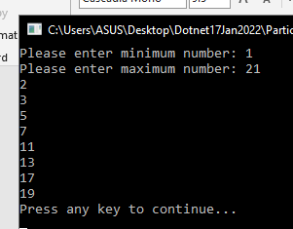

8) Take input from user until the user enters a negative number and find the sum of all the numbers

that are divisible by 7

public void numsDivisibleBy7Q8()

{

int inputNum, sum = 0;

Console.WriteLine("Enter negative number to break the looping");

do

{

Console.Write("Please enter a number: ");

inputNum = Convert.ToInt32(Console.ReadLine());

if(inputNum % 7 == 0)

sum += inputNum;

} while (inputNum >= 0);

Console.WriteLine("Total sum of numbers which are divisible by 7 is "+sum);

}

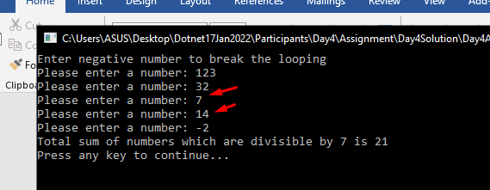

9) Take a 4 digit number from user and find the sum of all the digits

example - 1234 result should be 10

public void sumOf4digitsQ9()

{

int num, sum = 0;

int divNum = 1000;

Console.Write("Please enter a 4 digit number: ");

num = Convert.ToInt32(Console.ReadLine());

for(int i = 0; i < 4; i++)

{

int digitSplit = num / divNum;

num = num % divNum;

divNum = divNum / 10;

Console.WriteLine(digitSplit);

sum += digitSplit;

}

Console.WriteLine("The sum is " + sum);

}

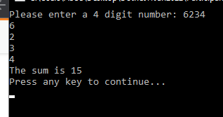

10) Take a 4 digit number from user and find if it is a palindrome or not

example - 1234 result should be Not a plaindrome

example - 1221 result should be Plaindrome

public void palindromeCheckerQ10()

{

int num, original, reverse = 0, sum = 0;

int divNum = 1000, mulNum = 1;

Console.Write("Please enter a 4 digit number: ");

num = Convert.ToInt32(Console.ReadLine());

original = num;

for (int i = 0; i < 4; i++)

{

int digitSplit = num / divNum;

num = num % divNum;

divNum = divNum / 10;

reverse += digitSplit \* mulNum;

mulNum = mulNum \* 10;

sum += digitSplit;

}

if (reverse == original)

Console.WriteLine(original + " is palindrome number.");

else

Console.WriteLine(original + " is not palindrome number.");

}

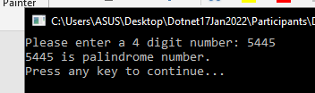

11) <https://leetcode.com/problems/powx-n/>

public void myPowCalculatorQ11()

{

int baseNum, powNum, powNum2;

int ans = 1;

Console.Write("Please enter the base number: ");

baseNum = Convert.ToInt32(Console.ReadLine());

Console.Write("Please enter the power number: ");

powNum = Convert.ToInt32(Console.ReadLine());

powNum2 = powNum;

while (powNum != 0)

{

ans \*= baseNum;

--powNum;

}

Console.WriteLine(baseNum +" power with "+ powNum2 + " equal to "+ans);

}

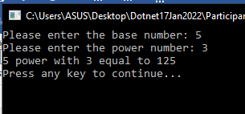

12) <https://leetcode.com/problems/happy-number/>

public void isHappyNumberQ12()

{

int num, num2 = 0 , result;

Console.Write("Please enter a number : ");

num = Convert.ToInt32(Console.ReadLine());

result = num;

while (result != 1 && result != 4)

{

result = happyNumVerification(result);

}

if (result == 1)

Console.WriteLine(num + " is a happy number");

else if (result == 4)

Console.WriteLine(num + " is not a happy number");

}

public int happyNumVerification(int num)

{

int rem = 0, sum = 0;

while (num > 0)

{

rem = num % 10;

sum = sum + (rem \* rem);

num = num / 10;

}

return sum;

}

